EXPT.NO : 1A | TO COMPUTE DISTANCE TWO POINTS TAKING INPUT
DATE:

AIM

ALGORITHM

PROGRAM
import math
x1=float(input("enter the x1: "))
x2=float(input("enter the x2: "))
y1=float(input("enter the y1: "))
y2=float(input("enter the y2: "))
a= x2 - x1
b= y2 - y1

d=math.sqrt(a**2 + b**2)
print("The distance is: ",d)
print("The round of value is: ",round(d,2))

OUTPUT
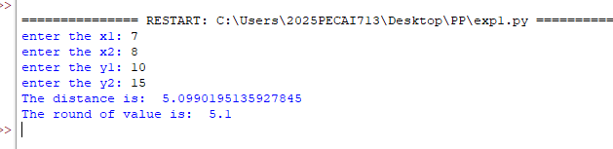

RESULT

EXPT.NO : 1B | PRORGRAM TO PERFORM ARITHMETIC OPERATIONS
DATE:

AIM

ALOGORITHM

PROGRAM
n1 = float(input("Please Enter the First Value Number 1: "))
n2 = float(input("Please Enter the Second Value Number 2: "))
a= n1 + n2
s = n1 - n2
m = n1 * n2
d= n1 / n2
o = n1 % n2
e = n1 ** n2
print("The Sum of two numbers", a)
print("The Subtraction of two numbers", s)
print("The Multiplication of two numbers", m)
print("The Division of two numbers", d)
print("The Modulus of two numbers", o)
print("The Exponent Value of two numbers", e)

OUTPUT
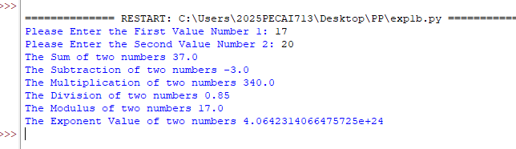

RESULT

EXPT.NO : 2 | PROGRAM TO DEMONSTRATE DIFFERENT NUMBER DATA TYPE IN PYTHON
DATE:

AIM

ALGORITHM

PROGRAM
# Integer
a = 20
print(a)
print(type(a))

# Float
b = 20.5
print(b)
print(type(b))

# Complex
c = 69j
print(c)
print(type(c))

# String
s = "Github.com/rohith2608-eng"
print(s)
print(type(s))

# List
l = ["Git", "hub", "rohith2608-eng"]
print(l)
print(type(l))

# Tuple
t = ("Python", "from", "Github.com")
print(t)
print(type(t))

# Boolean
flag = True
print(flag)
print(type(flag))

# Bytes
by = b'Hello'
print(by)
print(type(by))

OUTPUT
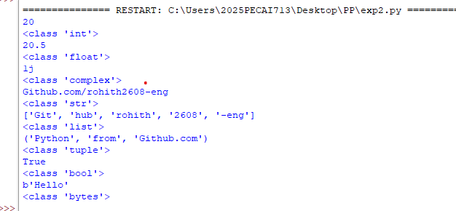

RESULT

EXPT.NO : 3 | DEVELOP A PYTHON PROGRAM TO DEMONSTRATE VARIOUS CONDITIONAL STATEMENTS
DATE:

AIM

ALGORITHM

PROGRAM
# Number is even or not
n = int(input("Enter the number: "))
if n % 2 == 0:
print("\nIt's even")
else:
print("\nIt's odd")

# Finding the factorial of a number
f = int(input("Enter the number: "))
if f < 0:
print("Factorial not defined for negative numbers")
else:
fact = 1
for i in range(1, f + 1):
fact *= i
print("Factorial =", fact)

# Prime number check function
def is_prime(n):
if n <= 1:
return False
for i in range(2, int(n ** 0.5) + 1):
if n % i == 0:
return False
return True
# Prime numbers in range
def primes_in_range(start, end):
primes = []
for num in range(start, end + 1):
if is_prime(num):
primes.append(num)
return primes
start = int(input("\nEnter start range: "))
end = int(input("Enter end range: "))
print("Prime numbers:", primes_in_range(start, end))

OUTPUT
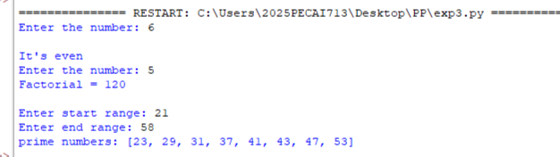

RESULT

EXPT.NO : 4 | IMPLEMENT USER DEFINED FUNCTIONS USING PYTHON
DATE:

AIM

ALGORITHM

PROGRAM
def add(a,b):
sum = a + b
return sum

x = int(input("Enter the number: "))
y = int(input("Enter the number: "))
result = add(x,y)

print("The sum is ",result)
OUTPUT
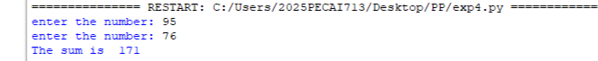

RESULT

